**INTRODUCTION**

**Class Diagram**: Class diagrams describe the static structure of a system, or how it is structured rather than how it behaves. These diagrams contain the following elements:

1. **Classes** which represent entities with common characteristics or features. These features include attributes, operations, and associations.

2. **Associations** which represent relationships that relate two or more other classes where the relationships have common characteristics or features. These features include attributes and operations.

***ATM MANAGEMENT System***

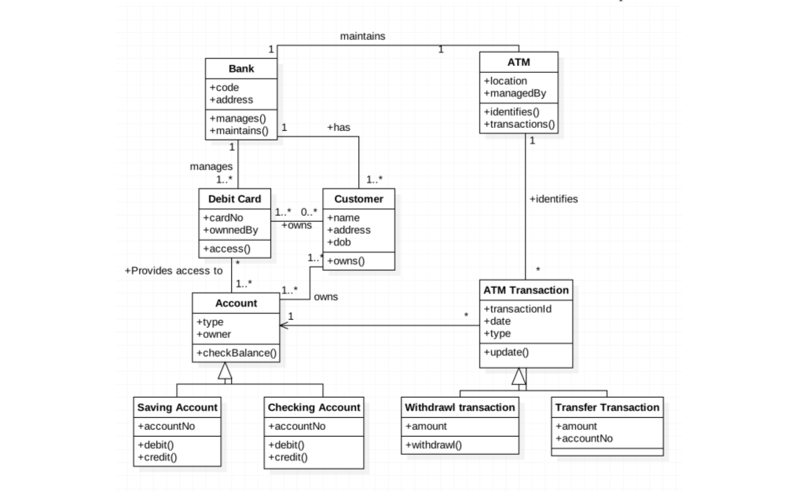

**DISCRIPTION**

* First comes the bank class which contains code and data members. It also has the methods of manages and maintains which can be called for other classes for example debit card, atm.
* ATM class for transaction the amount and identify the account.
* Debit card class to access the account.
* Customer class for his own details.
* Account class for account details for example current and saving account which are also managed as separate classes.
* Class for transaction to process the amount.
* Two inherited classes from the transaction to withdraw and transfer the cash respectively.